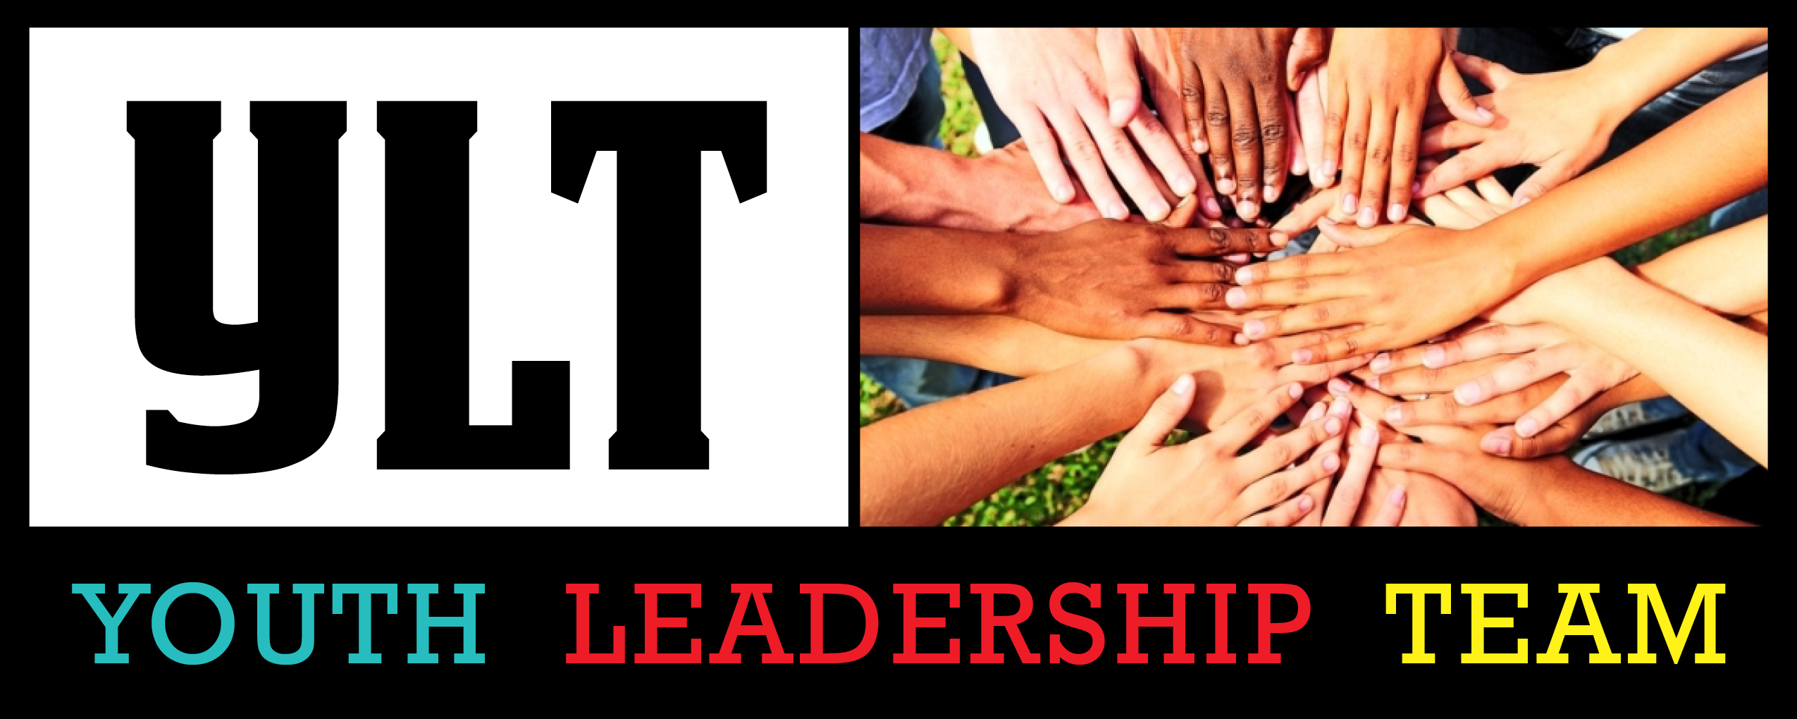

The Christian Church (Disciples of Christ)
Pacific Southwest Region
Are you full of great ideas? Passionate about people? Do you feel God calling you to lead?

The Youth Leadership Team (YLT) is a group of youth, grades 9 -12, and adults who work together to create amazing camp experiences and spread the word about youth ministries in the PSWR. This community of leaders spend time together in prayer, worship and leadership development learning how to best serve God, peers and faith communities.
Responsibilities include, but are not limited to, attendance at all YLT meetings (there are at least 6 a year) and regional camps (summer and winter). In addition, YLT members must be willing and able to participate fully in the work of planning and facilitating these events.
Applicants must be a member of, or an active participant in, a Christian Church (Disciples of Christ) congregation within the Pacific Southwest Region.
You can apply for YLT by filling out the enclosed application.

2019 YOUTH LEADERSHIP TEAM APPLICATION
The Christian Church (Disciples of Christ) of the Pacific Southwest Region

This section to be filled out by the applicant (PLEASE PRINT CLEARLY):

_____________________________________ ___________________________________________
First & Last Name E-mail Address

_____________________________________________________________________________________________
Street Address City State Zip Code

_____________________________________ ___________________________________________
Cell Phone # Home Phone #

____________________ ___________ _______________ _________________
Birth Date (M/D/Y) Age Grade Gender

I would like to be a member of Youth Leadership Team (YLT) because: ___________________________________

_____________________________________________________________________________________________

_____________________________________________________________________________________________

_____________________________________________________________________________________________

I am involved in the following activities at church: ____________________________________________________

_____________________________________________________________________________________________

_____________________________________________________________________________________________

These are the other major responsibilities I have right now: (school, job, clubs, sports, etc.)

_____________________________________________________________________________________________

_____________________________________________________________________________________________

In my spare time I like to: ________________________________________________________________________

_____________________________________________________________________________________________

What would your transportation to meetings and events be? _____________________________________________

_____________________________________________________________________________________________
Please mail completed applications to:
PSW Regional Office 115 E Wilshire Avenue, Fullerton, CA 92832
Questions: (626) 296-0385 or bjbarlow@docpswr.org
MY STATEMENT OF FAITH

Using the space below, please share with us your thoughts/feelings about where you are on your spiritual journey:

*** This application also requires 2 letters of recommendation to be valid.***
(1 Pastor/1 Other)
Please mail completed applications to:
PSW Regional Office 115 E Wilshire Avenue, Fullerton, CA 92832
Questions: (626) 296-0385 or bjbarlow@docpswr.org

YOUTH LEADERSHIP TEAM COVENANT
Youth Covenant:
1. I will attend every meeting of the Youth Leadership Team (YLT). I understand that I may miss (partial or an entire) one meeting or event (see #4 below) with a very good reason, which must be discussed with and approved by the YLT adults prior to the meeting or event date. I understand that missing a meeting or an event without doing any of the above prior to the meeting or event date may be cause for dismissal from YLT. I also understand that after missing (partial or an entire) one meeting or event that I am required to have 100% attendance at and participation in all YLT meetings and events for the remainder of the YLT year. I understand that failure to do so may result in my dismissal from YLT.
2. I understand that communication is an important part of my responsibility as a member of YLT. Therefore, I will check my e-mail regularly at the e-mail address I provided to the YLT adults and reply promptly when asked to do so. I will also make and return phone calls regarding YLT business in the same manner. I agree to immediately communicate with the YLT adults any e-mail, phone number or mailing address changes that may occur.
3. I recognize that any YLT responsibility that I take on (i.e. tasks/assignments for an event, phone calls, or an elected council position) is important and that the follow through is imperative. Failure to follow through on any responsibilities without communication to the YLT Adults that I am in need of assistance will be cause for dismissal from YLT.
4. I agree to attend all Christian Church (Disciples of Christ) of the Pacific Southwest Regional youth events including (but not limited to) summer camp, FEB Camp, and the youth events during the Regional Assembly. I recognize that missing any regional youth event without following the steps listed in #1 of this covenant will be cause for dismissal from YLT.
5. I agree to abide by all regional camp and youth event guidelines and recognize that breaking any of these guidelines could lead to my dismissal from YLT. A copy of all guidelines is available by request.
6. I agree to regularly attend worship, church school and youth fellowship meetings at my local Disciples of Christ church. I understand that the adult leadership of YLT has the right to contact my pastor and/or youth leader in regard to my participation in my local congregation and that if I am not regularly attending any of the above, I may be dismissed from YLT.
7. I recognize that my academics are equally as important as my position on YLT.
8. I recognize the importance of living my faith daily and will continue to grow in my faith and relationship with God throughout my term on YLT.
9. I understand that I am to be a positive role model and that a higher standard is being asked of me as a YLT member. I agree to support and encourage, as well as, minister to and with my fellow YLT members, the youth of my local church and the youth of the PSW Region to the best of my ability. I understand that if I do not live up to this standard I may be placed on an intentional covenant period facilitated by our YLT Adult leadership to help discern my future participation with YLT.
________________________________________________ _____________________
Applicant’s Signature Date

Parent and Legal Guardian Covenant: Please read carefully before signing. This section must be signed below for this covenant to be complete. The position for which your child holds as a member of the Youth Leadership Team for the Christian Church (Disciples of Christ) of the Pacific Southwest Region is a very important one and one in which much is expected. Those selected for the position have the potential for exemplary leadership. It is important that they receive your support for their 100% participation in the work and ministry of YLT. Your help may be needed with transportation, minimal long distance phone calls, e-mails, encouraging completion of their responsibility for an event, etc. As your child signs the above covenant, they are making a strong commitment that will be a learning experience for life. Your support of that covenant will be part of that growth and training. With this in mind, we also ask you to sign a covenant of support. I give my permission for my child to be a member of the Youth Leadership Team and will give my support to insure that the above promises are kept.
________________________________________________ ___________________________
Parent or Legal Guardian’s Signature Date
Please mail completed applications to:
PSW Regional Office 115 E Wilshire Avenue, Fullerton, CA 92832
Questions: (626) 296-0385 or bjbarlow@docpswr.org

